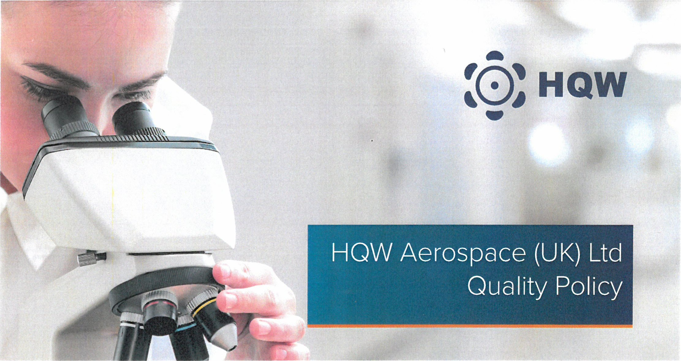
HQW Aerospace (UK) Ltd upholds the following in support of its Quality policy:
Provision of high quality products and support which meet or exceed the expectations of our customers and are fit for purpose.
Operate the business to fulfil the requirements of
AS 9100: Revision D
AS 9120: Revision B

Enhance the skills of the organisation through review and actively pursuing an ongoing training policy and equipment investment, with the objective being to prepare all staff to perform their work more effectively.
Promote the culture of continual improvement, risk management and the philosophy of getting things done right first time.
Effectively controlling the supply chain to ensure all materials are available when required meeting commercial, delivery and quality requirements.
To provide governance by continuous development of the Quality Management System through effective internal auditing and management review to provide effective corrective and preventative actions.
Everyone is responsible for the Quality of HQW Products and Services ensuring that we maintain the exacting standards and specifications established. Delivery and Output requirements are not an allowable reason to fail to meet these criteria.

Neil Morris | Mark Wakeham | Dave Tew | Gary Hughes
Trevor Metherell | Justine Descamps | John Dyer | Adam Wellington

